Trans Dimension Launch Event

Event Manager  
Expression of Interest

**What is the Trans Dimension project?**

GI is about to launch a website called 'The Trans Dimension'. This is an "infoshop" style site with events, services and general information for the London trans community. We hope it will be a really awesome resource to help isolated trans people connect with other people near them they might not know; and also provide community support in face of current trans adversity. Our software collates each groups’ information, keeping it accurate and up to date. We will publish an accurate public directory of trans and disability access information, gathered during the process.

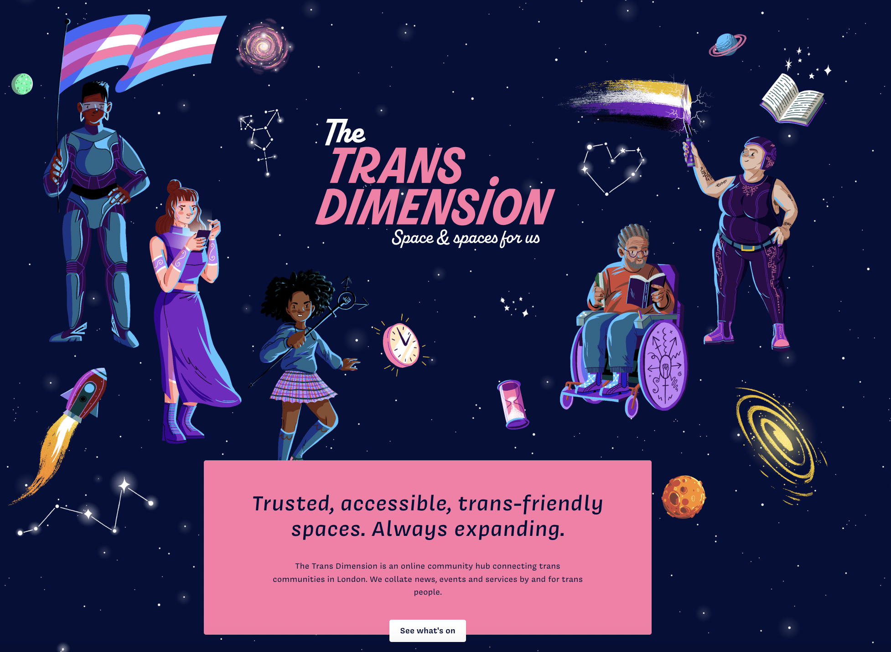

**What are we looking for?**

We are planning an event to launch this project and need an experienced Events Manager to make this happen. The event itself shall be a party/celebration of the launch of The Trans Dimension, but also the opportunity to celebrate trans groups in London.

There are about 30 organisations involved in the project and we expect the launch event to have about 50-100 attendees, from the partner organisations and the wider community.

The event will need curational design: the website is themed around space, and should be an accessible event, for all ages, so those are several aspects to consider.

There should be stalls for the partners to promote themselves; refreshments; photographers and press invited. This will be the first time most of the public will have heard of the project, so we want to make it something to shout about.   
  
**What the work will include**  
The Event Manager will be responsible for:

* Liaising with the GI team member responsible for the event in order to confirm the brief
* Researching a venue, (with reference to a range of access needs), then booking and liaison.
* Creating an invite and agreeing invite list with stakeholders at GI
* Sending invites (including follow-ups), managing attendee information, including obtaining information on access needs, and agreement on what can be shared for networking purposes with other attendees.
* Sourcing materials and resources
* Arranging catering
* AV as required
* Managing the budget, ensuring all receipts are documented and presenting a financial report after the event.
* Evaluating the event (with attendees and the Event Owner) and summarising data for a funder report.
* Any other aspects that are identified via the brief to make the event a fabulous success!

Timeline: We would like to have the event at the start of August, in the early evening, with an outside area.

**Cost**

Indicative budget is £12,500 (incl VAT) plus the Event Manager fee (capped at 16 days @ £250 pd incl VAT).

**Next steps**

If you are interested in this work, please send a short email outlining your previous experience to [georgie.mcvicar@genderedintelligence.co.uk](mailto:georgie.mcvicar@genderedintelligence.co.uk). You are welcome to attach a CV if that is relevant. We welcome interest from across our communities and are keen to hear from individuals with previous experience of a range of events (family / community as well as professional / corporate).

The deadline for applications is 16:00 22nd June.

We plan to have initial conversations with shortlisted applicants on Friday 24th June with a view to making a decision by Monday 27th June. Due to the timeline we would like work to start as soon as possible, but aim to be flexible in how / when the work is delivered (within agreed parameters). Please indicate in your email if you anticipate a problem with any of the above dates or the timeline (e.g., if you have other commitments between now and August which might clash with this work).